Caravaggio, Rest on the Flight to Egypt

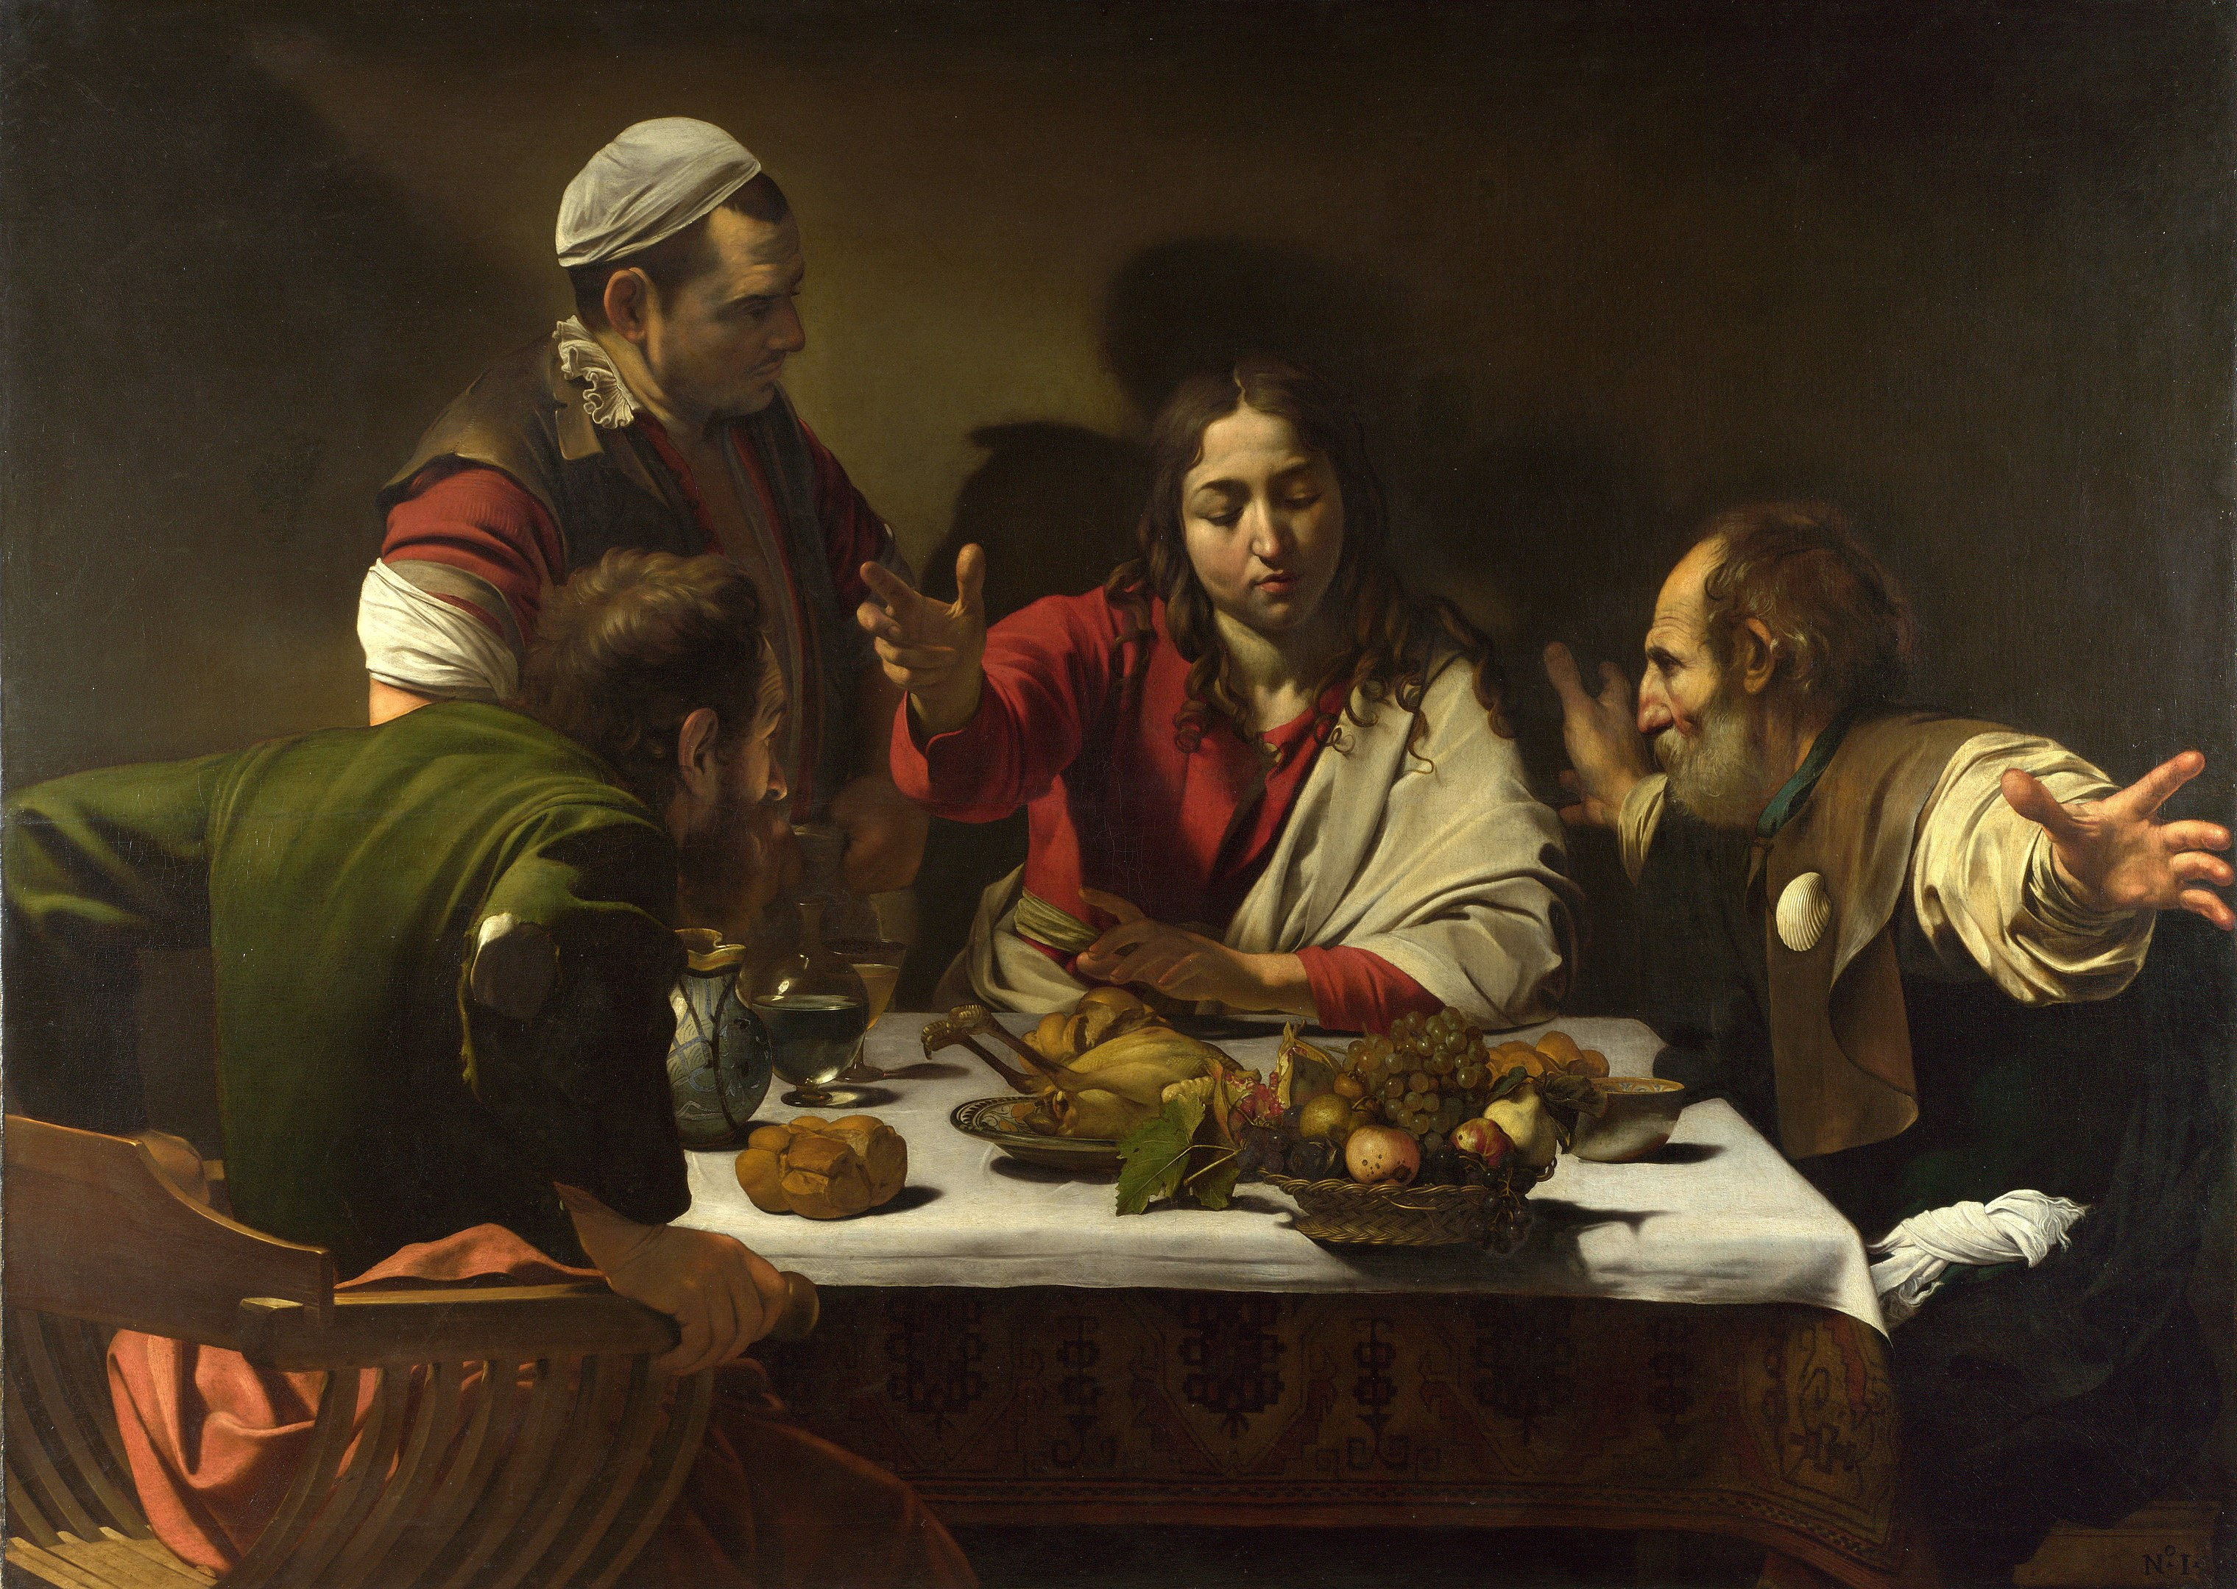
Caravaggio, The Supper at Emmaus, 1601

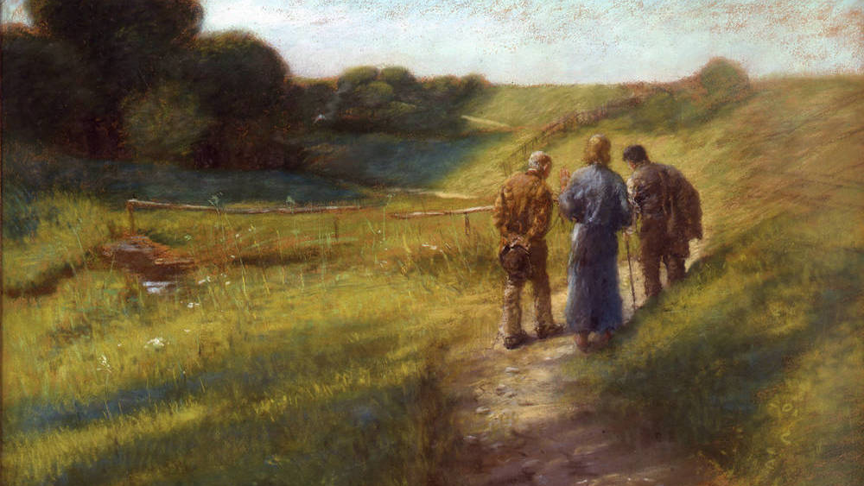
Von Uhde, The Walk to Emmaus

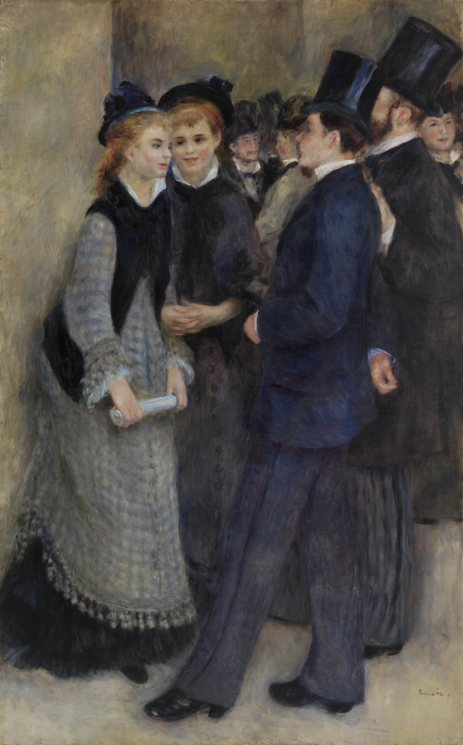
Renoir, Leaving the Conservatory

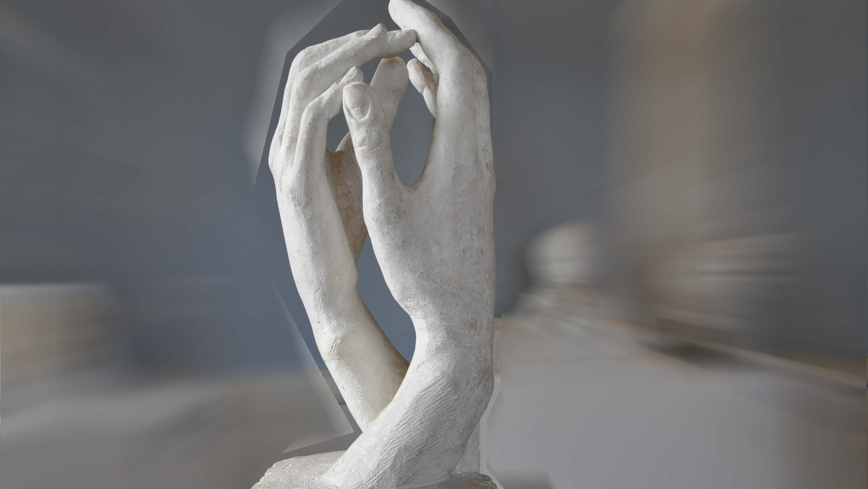
Rodin, Cathedral

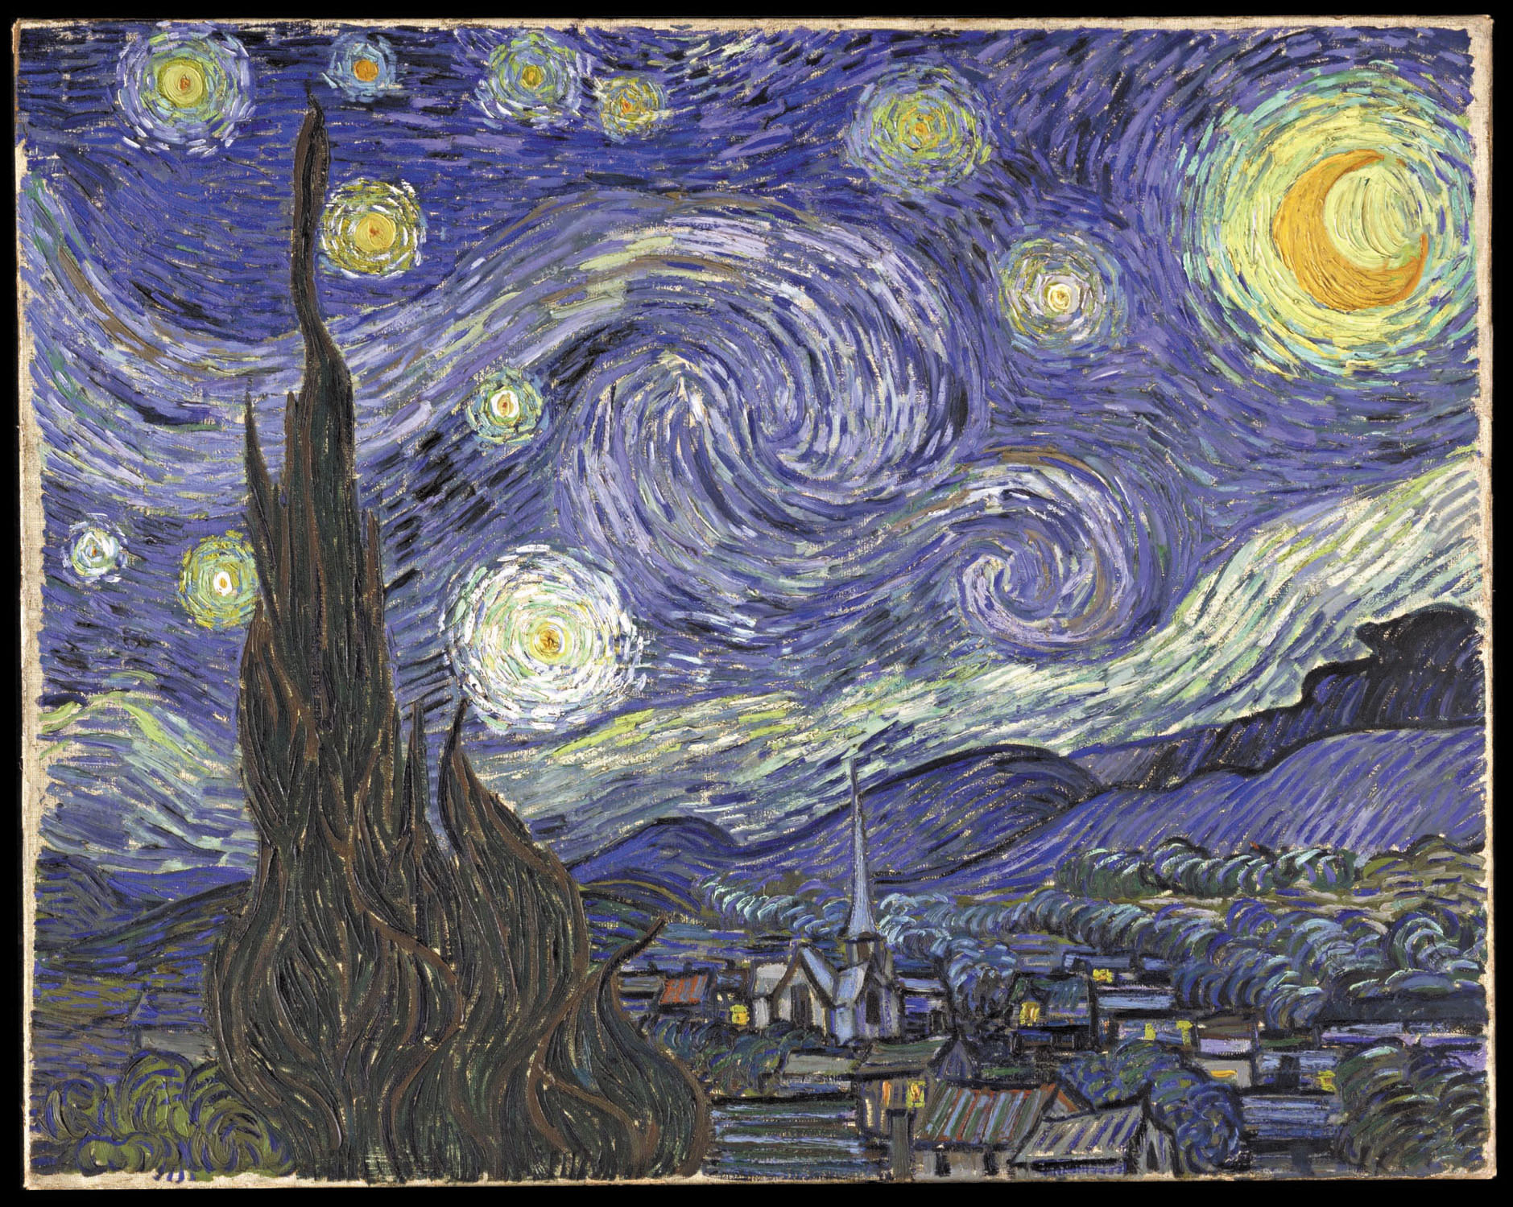
Van Gogh, The Starry Night

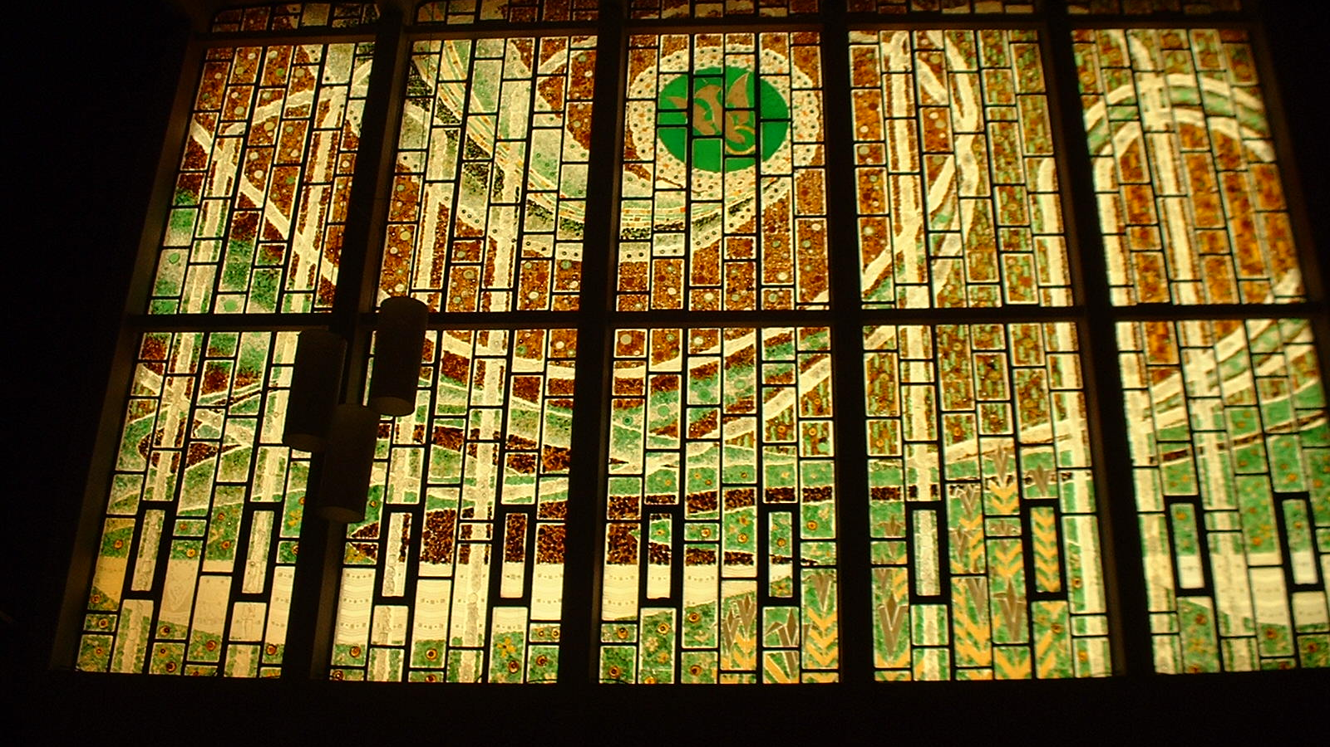
Sr. Collette, Holy Name of Mary Chapel

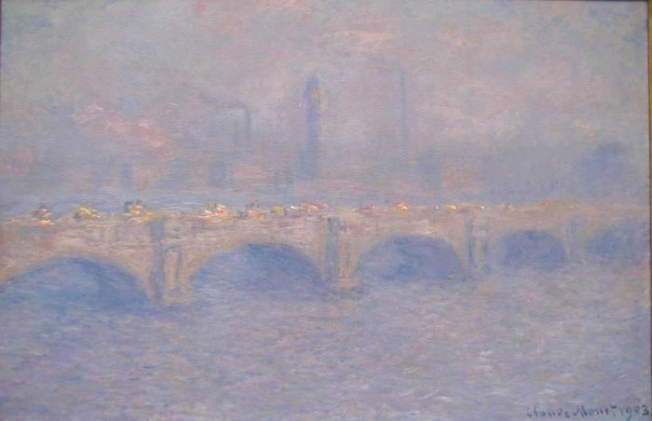

Monet, Waterloo Bridge, Sunlight Effect, 1903

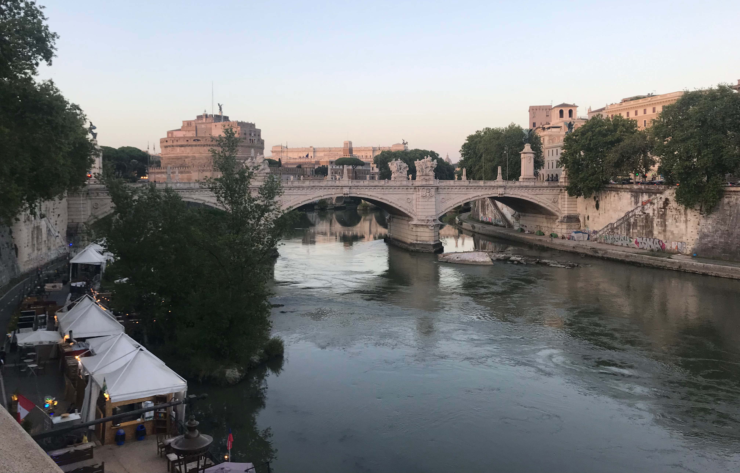

Ponte Vittorio Emanuele II, 2019
Photo by Les Miller

Capilano Suspension Bridge, 2019
Photo by Les Miller

