Waterloo Bridge, Sunlight Effect

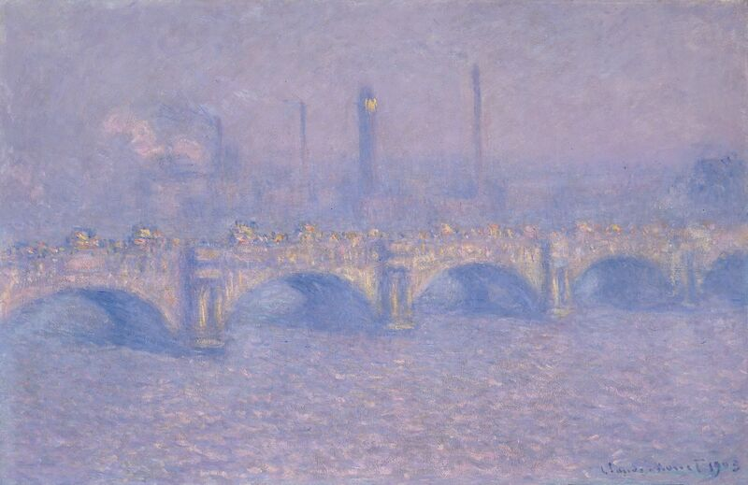

Look at this painting. What mood do you sense? What do you notice? Does it attract you? Why? Where is the sacred present for you in this image? Let’s add some context now to deepen our experience of the painting.

Claude Monet the great impressionist painter was a frequent visitor to London about 120 years ago. He stayed at the Savoy Hotel where he painted Waterloo Bridge over 40 times! He loved the interplay of light as it danced off the river, the bridge, the clouds and the south bank of the Thames. This image from the Chicago Art Institute captures sunset.

Bridges cross over difficult parts of the landscape: rivers and deep valleys. A bridge is built because the normal road won’t work as well. When we look at the journey of our life, a bridge represents the ways we deal with the difficult moments, the challenges where we have to pay particular attention to our path.

Returning to this image, we see the Thames river which at this time was terribly polluted, little more than an open sewer. The bridge itself badly needs repair, it will be replaced a few years later. Crossing the bridge, we see a traffic jam as commuters make their way across to south bank. That far shore is lined with factories pouring noxious smoke into the atmosphere.

Let’s reflect on the scene again. What does the bridge symbolize for you?

Here are some of the responses I’ve heard when I’ve shared this work with parents, catechists and Catholic teachers:

Despite the objectively nasty aspects of the scene, there is a definite beauty here. Dostoevsky tells us “beauty is God’s language”, so even in these dark places, God’s light can shine through.

As a teacher and catechist and parent, I feel like this bridge. I’m a bit decrepit myself; from the moment I wake up in the morning it’s rush hour. I’m busy. But on the other hand I do help my kids cross the bridge from ignorance to understanding. I literally help them as a bridge over the troubled waters of their lives.

It’s all about connection. The bridge brings things together. I bring kids together with learning; I bring kids together in the classroom community, when I’m at my best, I help students articulate and work towards their dreams, an important connection. In our Catholic schools I also connect many of the kids with their faith. They don’t always get that at home or in the community.

Another said, it bothers me that this image is beautiful. It shouldn’t be. It masks pollution and the rat race. It’s decorative or at best indulgent when we are called to be prophetic and point out the problems of our time. It’s little wonder considering Monet could afford to stay at the Savoy … it’s a hidden portrait of privilege!

I love that last perspective. The art is successful because it has provoked, it has engaged the passions.

It’s not that Monet had all these ideas in mind when he painted Waterloo Bridge, but he did unleash possibilities when putting paint on canvas, many unconsciously. This is a bridge that connects the secular with the sacred.

Where, then, is God in this experience of exploring this image? Take some time in contemplation to ponder how God is present to you. What are the bridges in your life that need repairing?

Source: https://www.artic.edu/artworks/20701/waterloo-bridge-sunlight-effect

