Visio Divina invites us to seek the sacred in art, word and silence.

- We are praying with the Holy Family through Caravaggio’s Rest on the Flight to Egypt. It is particularly appropriate to pray with this art in the Christmas season and into January, particularly on the Feast of the Holy Family.

- Let’s prepare ourselves, ensuring that our prayer space is free from distractions. Have an image available in print or on a screen. Let’s set ourselves for deeper prayer… quieten yourself … focus on your breath … Gaze at the image… Open yourself to the scene. Look at the angel playing the violin, the wings, the white cloth… Joseph holding the music … his face … his robes … his feet … the donkey in the background … Mary … the expression on her face … her hands … her garments … her feet … Jesus and the way he is being held … the background landscape… the vegetation … the sky. Take note of the emotions that this initial viewing evokes.
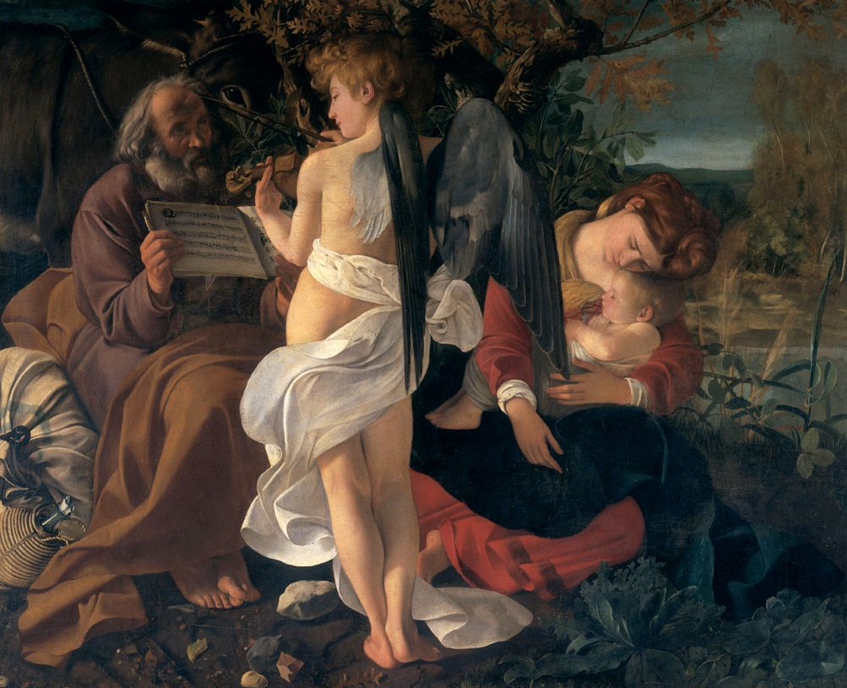
- Rest in this painting, noticing the ways that the sacred is present.

- This painting is taken from an imagined stop on the flight of the Holy Family from Bethlehem on their way to Egypt. Here is the account of this journey in Matthew 2:13-15.

Now after [the magi] had left, an angel of the Lord appeared to Joseph in a dream and said, “Get up, take the child and his mother, and flee to Egypt, and remain there until I tell you; for Herod is about to search for the child, to destroy him.” Then Joseph got up, took the child and his mother by night, and went to Egypt, and remained there until the death of Herod. This was to fulfill what had been spoken by the Lord through the prophet, “Out of Egypt I have called my son.”

- What stands out for you about this reading considering the painting? Imagine yourself in the scene…What are you sensing? What is the mood? What aspects of the passage are captured in the art? What are the details in this painting that suggest the sacred?

- Let’s enter the prayer of consideration. The artist is Michelangelo Merisi da Caravaggio a baroque painter. This 1597 canvas was his first large scale project and shows many of the features that set the tone for artists of the baroque period: dramatic settings, a contrast between light and dark and realistic settings.

- Canadians can take great pride in playing a great role in bringing the Feast of the Holy Family into the universal Catholic liturgical calendar. Many of the early settlers in New France brought a devotion to Jesus, Mary and Joseph from France, but it wasn’t until 1663 that St. Francois-Xavier de Montmorency-Laval, Quebec’s first bishop, endorsed the Confraternity of the Holy Family. This group established liturgical practices that were adopted in the Quebec diocese and gradually spread world-wide. Pope Leo XIII saw the movement as an antidote to the pressures on family life brought about by industrialization and urbanization in the late 1800’s. He encouraged the celebration in dioceses that wished to celebrate this feast. Meanwhile, in Canada, this devotion to the Holy Family contributed to the establishment of two great shrines: Sainte-Anne-de-Beaupré and St. Joseph’s Oratory.

- Pope Benedict XV was greatly troubled by the further social impact of the First World War on families, so he amplified the status of the Holy Family by making it a universal Feast in the Roman Calendar. In 1969 in the pontificate of St. Paul VI, the date of the celebration was fixed on the Sunday after Christmas Day.

- St. Paul VI also made a valuable contribution to our understanding of the Holy Family in Nazareth.

Nazareth is a kind of school where we may begin to discover what Christ’s life was like and even to understand his Gospel. Here we can observe and ponder the simple appeal of the way God’s Son came to be known, profound yet full of hidden meaning. And gradually we may even learn to imitate him.

Here we can learn to realise who Christ really is. And here we can sense and take account of the conditions and circumstances that surrounded and affected his life on earth: the places, the tenor of the times, the culture, the language, religious customs, in brief, everything which Jesus used to make himself known to the world. Here everything speaks to us, everything has meaning. Here we can learn the importance of spiritual discipline for all who wish to follow Christ and to live by the teachings of his Gospel.

- St. Paul VI identifies three gifts that the Holy Family gives to us in this School of Nazareth: the catechesis of silence, the communion of love, and the dignity of work. These points are beautifully illustrated in Caravaggio’s Rest on the Flight to Egypt.

- The catechesis of silence. All figures are silent, except for the heavenly music bringing divine beauty into their lives. The silences in the Holy Family’s life teach us to find silences in our own lives to listen for God’s music and be present to God’s beauty. Like the Holy Family, we are all on a journey through the tumult of our times, so much in need of silence beyond the chaos.

- The communion of love. Mary’s caress of her newborn son conveys the deep love that radiates from this canvas. This is a love that is born of vulnerability. All four figures have bare feet, they are literally grounded in God’s creation. But there is love that serves: Mary tending to her child, Joseph holding the music sheets and the angel playing the violin.

- The dignity of work. Joseph epitomizes the School of Nazareth in his silent devotion and ready service. Here he holds the pages of the sacred songbook to help the angel. May all our work be of service to the sacred, here and in heaven. St. John Paul II writes:

Human work, and especially manual labor, receives special prominence in the Gospel. Along with the humanity of the Son of God, work too has been taken up in the mystery of the Incarnation, and has also been redeemed in a special way. At the workbench where he plied his trade together with Jesus, Joseph brought human work closer to the mystery of the Redemption.
Redemptoris custos 22

- Consider our own families…our configurations … our journeys … many of us have origins in other countries, migrants like the Holy Family. How do we pass on the faith in our domestic churches? How do we model the faith? How do we provide a climate of trust that leads to faith? What prayer practices do we share?

- We also need to contemplate the first word in the title of the painting, rest. Our family life is often hectic and plagued with dangers. Many of us complain of exhaustion. As Linda Kavelin Popov advises, we need to move from a pace of haste to a pace of grace. We need the sabbath moments woven into our lives to let the sacred catch up to us, to hear God’s song.

- Let us take some rest in this Visio Divina. Rest in this journey of insight to allow ourselves to hear God’s music in our hearts. In our silence, we wrap ourselves in grace to simply be with God.

- Let’s contemplate these insights and images. What have been the moments of insight? … What has stirred you? … For what are you grateful? … What ideas and words do you want to pass on to others?

Sources:
Image found at Wikimedia Commons
Words of St. Paul VI at the Basilica of the Annunciation, 1964 https://www.vatican.va/content/paul-vi/fr/speeches/1964/documents/hf_p-vi_spe_19640105_nazareth.html
St. John Paul II Redemptoris custos 22 https://www.vatican.va/content/john-paul-ii/en/apost_exhortations/documents/hf_jp-ii_exh_15081989_redemptoris-custos.html

