Visio Divina
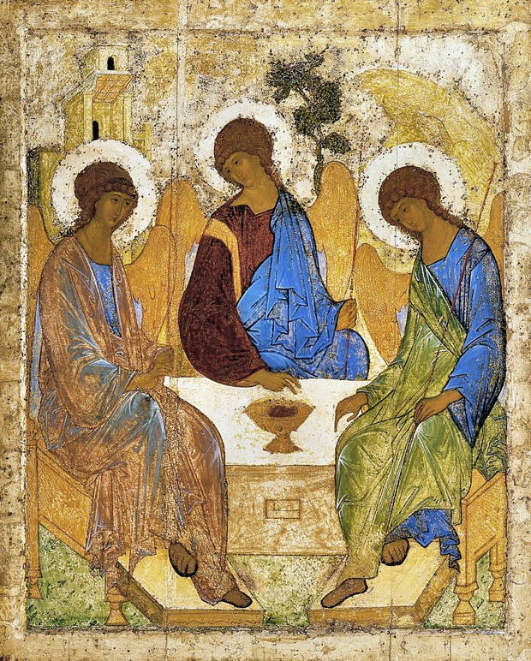
SEEING WITH THE EYES OF THE HEART

Visio Divina, or “sacred seeing,” is a way of praying with art that moves us into deeper communion with the holy. It follows a similar path to Lectio Divina or “sacred reading” In a world that is ever more inundated with images, Visio Divina requires us to slow down and truly see. We open the eyes of our hearts to see traces of grace in art. This practice does not require any special knowledge or appreciation of art, just a willingness to attend to and interact with the colours, textures, forms and overall impressions. You are usually provided spoken or written resource material to help you interpret the image. Visio Divina is an invitation to wonder and consider. The image comes alive with personal meaning. While Sacred Art is often the starting point for Visio Divina, we can also pray with the sacred spaces in which we worship, some secular art, creation and images arising in everyday life.
__________________________________________________________________

“In order to communicate the message entrusted to her by Christ, the Church needs art.” — St. John Paul II
__________________________________________________________________

PREPARATION
Prepare the resource material for the Visio Divina: make sure the art is visible to all if this is group prayer. This can come from digital, print, video or a live guide. If the art depicts a Biblical scene, open the Bible to that passage. Settle yourself in an appropriate prayer space. Centre yourself in quiet prayer.

GAZING
Gaze at the image. Look at the different sections. What do you notice? On what details do you focus? What emotions does it evoke? Gazing goes beyond looking. When we gaze, we go beyond the image into a sacred realm. We become aware of the glimmers of grace radiating through the image.

RESPONDING
If the passage depicts or evokes a Biblical scene, read the passage from the Bible slowly and meditatively. Respond to the image with prayer. How do you see or feel the sacred in this image?
CONSIDERING
Engage your imagination. Where are you in the artwork? What do you see from that perspective?
View, listen to or read the resource material slowly. Take a second, deeper look. What insights did the resource material produce? What questions remain?

RESTING
Gently gaze at the image for a while. How does this image lead you closer to God? Did it open a new awareness, or spark a conviction? Rest in this sacred space. Offer gratitude for insights gathered or questions raised.

ACTING
The outbreath of prayer is action. How does this prayer experience connect with your life? How can your insights help others? Which insight or part of the image do you most want to carry with you? St. Clare called this step, “Imitation.” How does this prayer help us to imitate Christ?

