Visio Divina invites us to abide in the sacred in art, word and silence.

- Welcome! We’ll be praying with this image of Divine Mercy painted by Eugeniusz Kazimirowski from instructions by St. Faustina. Bring yourself to quiet in front of this image.

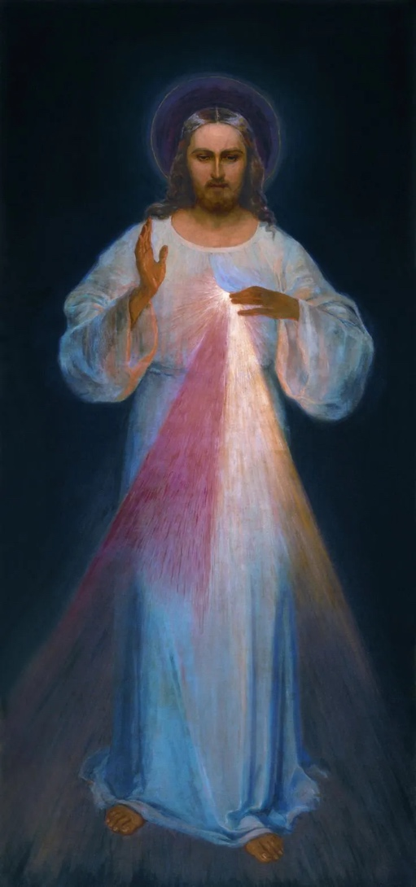
- Gaze at the image with gentle eyes. Focus on the dark background. … The halo … The face of Christ … his garment … the position of his feet … the feet themselves … His right hand raised in the gesture of blessing … His left hand pointing to his wound on his chest … The wound itself … The blue and red rays coming from the wound … At the bottom of the image we can just make out some words that when translated into English say, “Jesus, I trust in you.” … Now take in the whole image.

- Contemplate these accounts by St. Faustina about the image:

In the evening, when I was in my cell, I saw the Lord Jesus clothed in a white garment. One hand was raised in the gesture of blessing; the other was touching the garment at the breast. From beneath the garment, slightly drawn aside at the breast, there were emanating two large rays, one red, the other pale. In silence I kept my gaze fixed on the Lord; my soul was struck with awe, but also with great joy. After a while, Jesus said to me, Paint an image according to the pattern you see, with the signature: Jesus, I trust in You. I desire that this image be venerated, first in your chapel, and then throughout the world.

When, on one occasion, my confessor told me to ask the Lord Jesus the meaning of the two rays in the Image, I answered, “Very well, I will ask the Lord”. During prayer I heard these words within me: The two rays denote Blood and Water. The pale ray stands for the Water which makes souls righteous. The red ray stands for the Blood which is the life of souls.

Not in the beauty of the colour, nor of the brush lies the greatness of this image, but in His grace'.

- What words or phrases stood out for you? Gaze at the image of Divine Mercy again… what details strike you now? What overall feeling does the art give you? How are you encountering the sacred in the image and in the reading? How do you respond to God out of this experience?

- Let’s enter into the prayer of consideration where we meditate on insights from spiritual writers. Fr. Patrick van der Voorst tells us that, “For me the best aspect of the painting is the gentle walking pose of Jesus. One foot is slightly in front of the other. He keeps moving, just like his mercy and grace keep moving towards us as well. If we keep moving towards Him as well, then we will be saved 'not because of righteous things we had done, but because of his mercy' (Titus 3:5).”

6. St. John Paul II told us that, “This fire of mercy needs to be passed on to the world. In the mercy of God the world will find peace and mankind will find happiness! I entrust this task... to all the devotees of Divine Mercy”

7. Pope Francis told us, “This is the time for mercy. It is the favourable time to heal wounds, a time not to be weary of meeting all those who are waiting to see and to touch with their hands the signs of the closeness of God, a time to offer everyone, everyone, the way of forgiveness and reconciliation.”

8 We read “Jesus I trust in you.” How do I do this in my life? … Where do I need to trust min Jesus more? We are shown divine mercy so that we in turn can be merciful. … Where in our lives do we need to show mercy?

9. Close your eyes and let sacred silence wash over you. Rest in the merciful presence of Jesus. What words or images emerge? … Offer a prayer of gratitude for insights rising out of this experience.

Sources: Wikimedia
christian.art
vatican.va
Note: If you use the image by Adolf Hyla, revise points 1 and 2.

